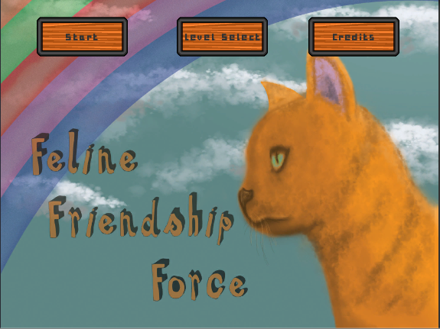

Feline Friendship Force

(FFF)

Acceptable Havoc

Version 1.2

|  |  |  |
| --- | --- | --- |
| **Position Title** | **Name** | **Signature** |
| Artist | Brennen Dumas |  |
| Programmer | Ashley Pancho |  |
| Level Designer | Dominique Stafford |  |
| Level Designer | Chris Wysocki |  |
| Programmer | Rui Xie |  |

**Document Revisions Table**

|  |  |  |  |
| --- | --- | --- | --- |
| **Version** | **Description** | **Requestor** | **Date** |
| 0.1 | Initial Google Doc | Despain | 09/28/17 |
| 0.2 | Transfer to Word Doc | Acceptable Havoc | 10/10/2017 |
| 0.3 | Updating GDD | Acceptable Havoc | 10/11/17 |
| 0.4 | Updating GDD | Acceptable Havoc | 10/18/17 |
| 0.5 | Updating GDD | Acceptable Havoc | 10/24/17 |
| 0.6 | Updating GDD | Acceptable Havoc | 10/26/17 |
| 0.7 | Updating GDD | Acceptable Havoc | 11/2/17 |
| 0.8 | Updating GDD | Acceptable Havoc | 11/7/17 |
| 0.9 | Updating GDD | Acceptable Havoc | 11/8/17 |
| 1.0 | GDD to Launch | Acceptable Havoc | 11/17/17 |
| 1.1 | Fixing Format & Splash Screen Update | Acceptable Havoc | 11/20/17 |
| 1.2 | Adding art sections and art elements to all parts of the GDD. | Acceptable Havoc | 11/21/17 |
|  |  |  |  |
|  |  |  |  |
|  |  |  |  |
|  |  |  |  |
|  |  |  |  |
|  |  |  |  |
|  |  |  |  |
|  |  |  |  |
|  |  |  |  |
|  |  |  |  |
|  |  |  |  |

Table of Contents

Table of Figures 5

Concept 7

High Concept 7

Game Pillars 7

Game Description 8

Gameplay Loops 9

Gameplay Minute 10

Puzzle Elements 12

Player’s Objective 14

Primary Objective 14

Secondary Objective 14

Controls 14

Interface 14

Nodes and the Laser Pointer 15

Node Placement 15

Cats 16

Cat Conveyance 16

Cat Placement 16

Cat Sprite 16

Dogs 17

Dog AI State 17

Dog Placement 18

Enemy Sprite 19

Additional Dog Sprites 19

Box 20

Box Placement 20

Box Art 20

Box Sound 20

Hose and Water 21

Hose and Water Conveyance 21

Hose and Water Placement 21

Invisible Objects 22

Invisible Object Placement 22

Cat Nip 23

Cat Nip Placement 23

Cat Nip Art 23

Base Background Asset Sprites 24

Modified Background Asset Sprites 24

Camera/HUD/UI 25

World Layout 26

Level Progression and Details 27

Level Progression Table 27

Level 1: Tutorial 1 28

Level 2: Tutorial 2 28

Level 3: Tutorial 3 29

Level 4: Bunny 29

Level 5: Smol Tank 30

Level 6: Tank Boi 30

Level 7: Man w Cane 31

Level 8: Thicc Sticc 31

Level 9: Signs 32

Level 10: New Dog Who Dis 32

Level 11: Hummer 33

Level 12: Mirrorz 33

Menu System 34

Menu Flow 34

Menu Descriptions 35

Menu Details 36

Installation 36

Title Splash Screen(s) 36

Main Menu 37

Credits Screen 37

Exit/Pause Screen 38

Game Over Screens 38

# Table of Figures

Figure 1 7

Figure 2, Core Loop 9

Figure 3, Secondary Loop 9

Figure 4 10

Figure 5 10

Figure 6 10

Figure 7 10

Figure 8 10

Figure 9 10

Figure 10 11

Figure 11 11

Figure 12, Interface 14

Figure 13, Node Connection Script 15

Figure 14, Player Script 16

Figure 15, Glow Controller Script 16

Figure 16, Cat Sprite 16

Figure 17, Dog AI Flow Chart 17

Figure 18, Dog Notice 18

Figure 19, Dog Confused 18

Figure 20, Enemy AI Script 18

Figure 21, Dog Sprite 19

Figure 22, Alert Sprites 19

Figure 23, Question Mark Sprites 19

Figure 24, Box Sprites 20

Figure 25, Box Audio Source Component 20

Figure 26, Hose Prefab 21

Figure 27, Pressure Plate Script 21

Figure 28, Watter Connection Script 21

Figure 29, Cat Nip Sprites 23

Figure 30, Background Art Sprites 24

Figure 31, Modified Background Art Sprites 24

Figure 32, UI 25

Figure 33, Tutorial 1 28

Figure 34, Tutorial 2 28

Figure 35, Tutorial 3 29

Figure 36, Bunny 29

Figure 37, Smol Tank 30

Figure 38, Tank Boi 30

Figure 39, Man w Cane 31

Figure 40, Thicc Sticc 31

Figure 41, Signs 32

Figure 42, New Dog Who Dis 32

Figure 43, Hummer 33

Figure 44, Mirrorz 33

Figure 45, Home Screen Menu Flow 34

Figure 46, In Level UI Flow 34

Figure 47, Guildhall Splash Screen 36

Figure 48, Acceptable Havoc Splash Screen 36

Figure 49, Main Menu 37

Figure 50, Credits 37

Figure 51, Exit/Pause Screen 38

Figure 52, Win Screen 38

Figure 53, Loss Screen 39

# Concept

## High Concept

Figure

* Feline Friendship Force (FFF) is a mobile turn based puzzle game where the player guides cats using a laser pointer to rejoice in the power of friendship.

## Game Pillars

**Challenging**

* We want our players to learn how to manipulate the systems in each puzzle and think about each move they will take to beat the game.

**Quick Attempts**

* We want each level to be a bite sized experience where players can iterate and quickly implement new strategies after each failed attempt.

**Approachable**

* We want players to be able to pick up the game and know exactly what they need to do and how they can interact with the game world.

## Game Description

* Feline Friendship Force (FFF) is a turn based puzzle game for android touchscreen devices. The game is centered around the player using a laser pointer to guide two cats to meet each other. The path is not so straight forward for the player, the path is blocked by dreaded water from a hose that was irresponsibly left on. Thankfully the water can be stopped if something stops on the hose, which is conveniently laid around the path. With the water obstacle gone the cats are one step closer to being united.
* Water isn’t the only obstacle in the way of the cats, there are dogs which patrol different sections of the level. A dog will chase after a cat if they are ever within the line of sight, causing the player to think twice before moving each turn. If a dog catches a cat then it’s game over for the cat and the player must retry the level, learning from their previous mistake. The dogs are not smart though and will chase after any cat it sees. This gives the player the ability to lead dogs to areas of the map and potentially even use the dog to stand on the hoses which opens paths that would otherwise be blocked by water. The player is challenged to learn the best strategies to lead the dogs around the map and do the players bidding.
* The back of an alley is a lonely place which needs to be defeated with Feline Friendship. Each level will have an even number of cats that need to be brought together to rejoice in the pure power of friendship. Every attempt should bring the player closer and closer to solving the levels, and once beaten will be enticed to try and see if there is better path.
* The tone of the game is made through the muted tones of the alley way. When the cats are apart there isn’t much color variance or joy to be had in the world. The laser pointer adds a bit of character to the world, but the world is still dark and dreary. When the two cats meet the world bursts with amazing happy colors and boy golly is the payoff rad!

## Gameplay Loops

Figure , Core Loop

Figure , Secondary Loop

**Core Loop**

* Plan – players must observe and think about how they are going to move the cats to beat any level.
* Move – The player moves the cat, ending the player’s turn.

**Secondary Loop**

* Lead – The player must lead the cats, and get the attention of the dogs to solve puzzles.
* Unblock – The player needs to unblock paths using the dog and the hose to solve puzzles.
* Meet – The goal is for players to guide both cats onto any one node.

## Gameplay Minute

Moving out of the way of the dog the cat begins to move towards their friend.

Players begin moving a cat to an adjacent node.

Figure

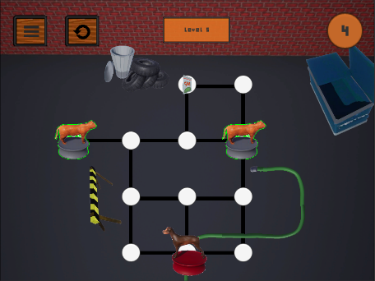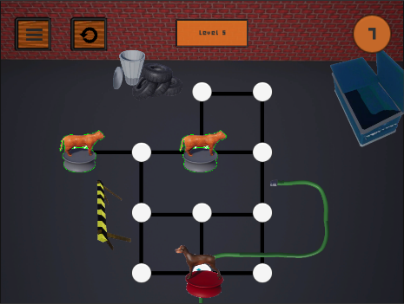

Figure

Players move the dog onto the pressure plate clearing the path.

With a direct path to the line the player moves the cat straight to their friend.

Figure

Figure

Figure

Figure

The player examines and decides which cat to move first.

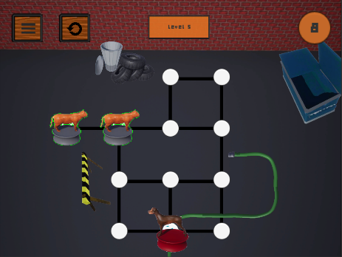

Figure

Figure

When both cats are on the same node the win screen shows the player what achievements they earned.

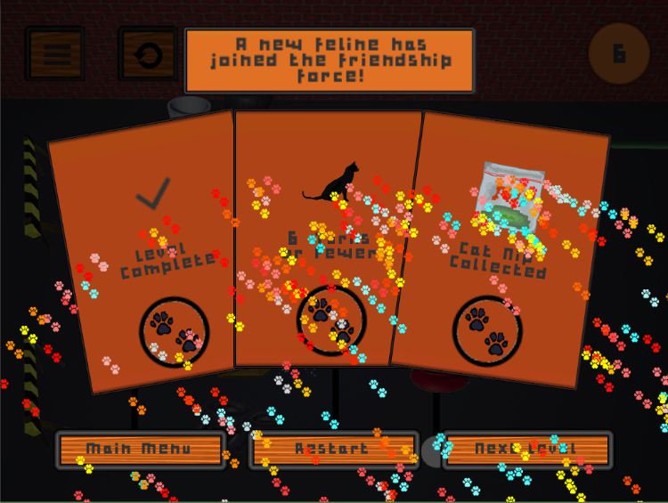

# Puzzle Elements

Player’s Objective 14

Primary Objective 14

Secondary Objective 14

Controls 14

Nodes and the Laser Pointer 15

Node Placement 15

Cats 16

Cat Conveyance 16

Cat Placement 16

Cat Sprite 16

Dogs 17

Dog AI State 17

All AI states 17

Still_AI 17

Chase_AI 18

Dog Placement 18

Enemy Sprite 18

Additional Dog Sprites 19

Box 20

Box Placement 20

Box Art 20

Box Sound 20

Hose and Water 21

Hose and Water Conveyance 21

Hose and Water Placement 21

Invisible Objects 22

Invisible Object Placement 22

Cat Nip 23

Cat Nip Placement 23

Cat Nip Art 23

Base Background Asset Sprites 24

Modified Background Asset Sprites 24

Camera/HUD/UI 25

## Player’s Objective

### Primary Objective

* Two cats meet each other on the same node to beat any level.

### Secondary Objective

* Beat each level using as little turns as possible.

## Controls

* Tap & Drag – The player’s only input is tapping and dragging. The player can only drag cats across one node at a time and can only move one cat per turn.

## Interface

Figure , Interface

* A1 - Level number
* A2 - Turn counter
* A3 - Spot indicating where the adjacent cat will move next
* A4 - Water obstacle that blocks dog's line of sight and cats/dogs path.
* A5 - Leak to stand on to toggle the water flow.
* A6 - Box that cats can use to hide from the dog's line of sight.
* A7 - Catnip collectible

## Nodes and the Laser Pointer

* Cats can only move on connected and unblocked nodes.
* Dogs can only move on connected and unblocked nodes.
* The player controls the cat through selecting [tapping] on a cat and dragging to an adjacent node [controlled through a laser pointer].

### Node Placement

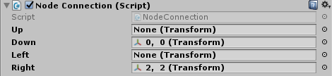

Figure , Node Connection Script

* + Each node has a Node Connection script, indicating how nodes in the level are connected.
  + When editing the level, check each Node Connection and put proper node object into the script according to the level layout.
  + All nodes are a minimum of 2.5 apart on the x-axis.
  + All nodes are a minimum of 2.5 apart on the y-axis.
  + No node should be placed at the top of the screen, otherwise it will block the UI.

## Cats

* Two cats must go to the same node to beat any level.
* If a cat cannot be reached by another then the player does not pass that level.
* If a cat dies, then the player does not pass that level.
* Cats can stand on the hose, unblocking the path with water on it.

### Cat Conveyance

* Cats will glow with a green shader effect when they are not in the line of sight of the dog.
* If a cat is in the line of sight of a dog the shader turns red.

### Cat Placement

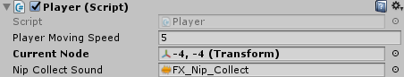

Figure , Player Script

* + Each player object has a Player script, controlling player’s movement and collision events.
  + When editing the level, check each Player and put proper node object into the script according to the player’s initial position.
  + The FX_Nip_Collect sound is on the Player script and activates when the player collects the cat nip.

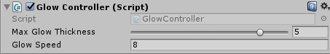

Figure , Glow Controller Script

* + Each player object has a GlowController script, controlling player’s shader effect.

### Cat Sprite

* 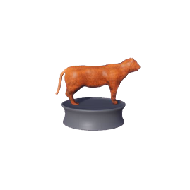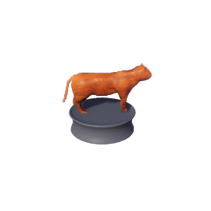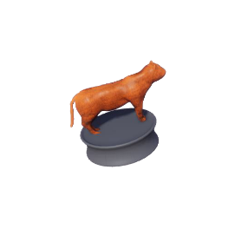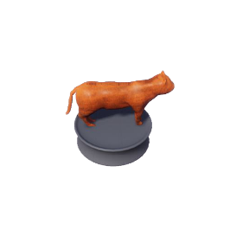The cat sprite for the player character.

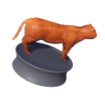

Figure , Cat Sprite

* All of these are saved as .png’s
* Cat sprite sizes are all saved at 512x512 pixels.

## Dogs

* If a dog lands on the same node as a cat, then the cat dies, and the player loses the level.
* Dogs can stand on the hose, unblocking the water on the path.

### Dog AI State

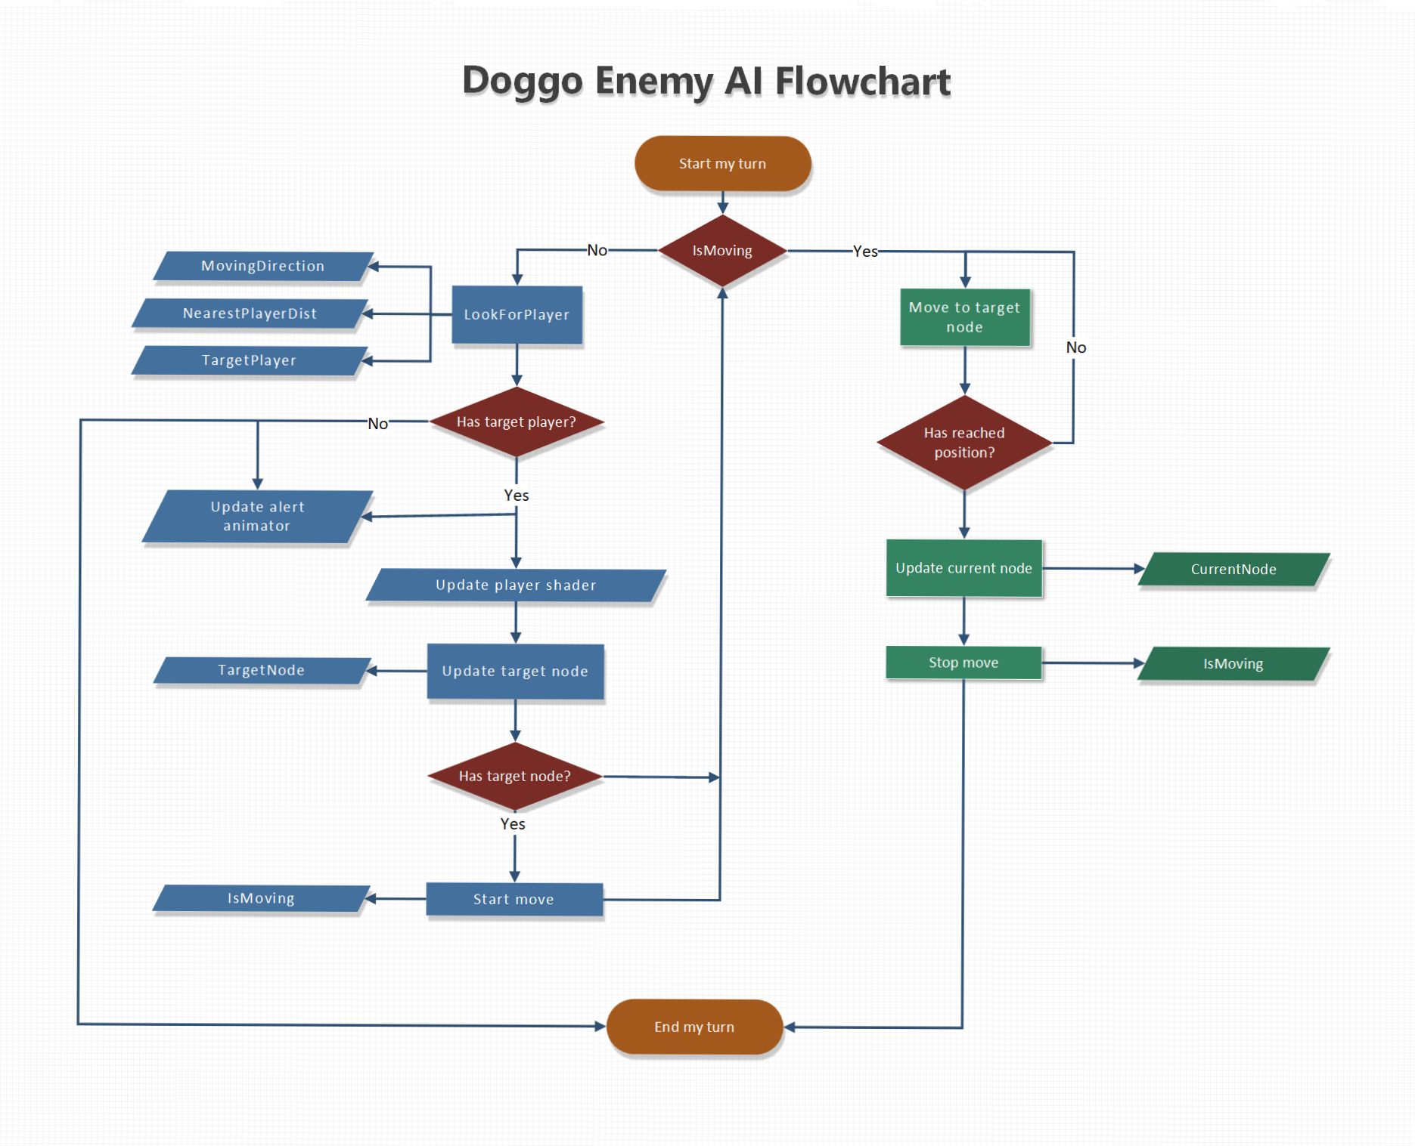

Figure 17, Dog AI Flow Chart

#### All AI states

* Dog checks for cat in any connected and unblocked up/down/left/right path.
* Dog can move only 1 node per turn.

#### Still_AI

* A question mark will appear over the dog’s head.
* Dog stays on one node checking for cats.
* Dog doesn’t move until it sees a cat.

#### Chase_AI

Figure , Dog Notice

* When a dog sees a cat, it enters Chase_AI state.
* An ‘!’ mark appears over the dog’s head while the dog is in Chase_AI state.
* The dog chases the closest cat.
* If two cats are the same distance away, the dog keeps following the first cat it was chasing.
* If two cats are seen at the same time by the same dog and are the same distance away the last moved cat is selected to be chased.
* 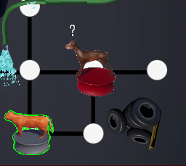The dog leaves Chase_AI state when a cat is not in a line of sight at the beginning of the dog’s turn.

Figure , Dog Confused

* When the dog leaves Chase_AI state a ‘?’ appears over the Dog’s head for one turn.

### Dog Placement

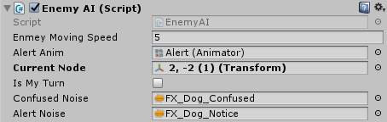

Figure , Enemy AI Script

* + Each enemy dog object has an EnemyAI script, controlling enemy’s AI behavior.
  + When editing the level, check each EnemyAI and put proper node object into the script according to the enemy’s initial position.
  + The FX_Dog_Notice and FX_Dog_Confused sounds are the Enemy AI script.

### Enemy Sprite

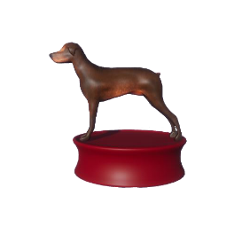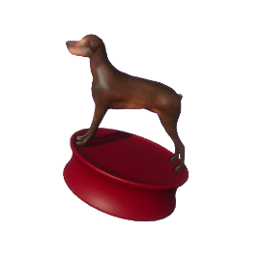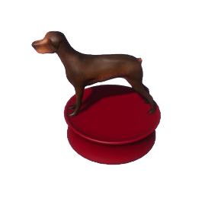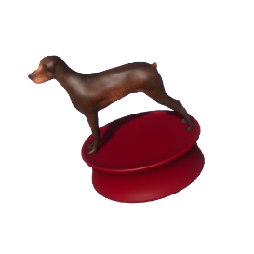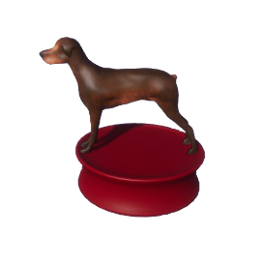

Figure , Dog Sprite

* All dog sprites are saved as .png’s
* Dog sprite sizes are all saved at 512x512 pixels.

### Additional Dog Sprites



Figure , Alert Sprites



Figure , Question Mark Sprites

* The Alert Sprite and the Question Mark sprite sheets are sized at 64x64 pixels
* The Alert Sprite activates when the Dog sees a Cat.
* The Question Mark activates when a Dog loses direct line of sight of a Cat.

## Box

* Cats can enter the box.
* Dogs cannot see a cat inside a box.
* Dogs cannot kill a cat inside a box.
* Boxes do not block the field of view for the dog.
* The box has a green shader when a cat is inside the box.
* A dog can stand on the box, but won’t kill the cat.

### Box Placement

* When editing the level, put box elements above proper node according to the level layout. There’s no other script setting required for box elements.

### Box Art

* 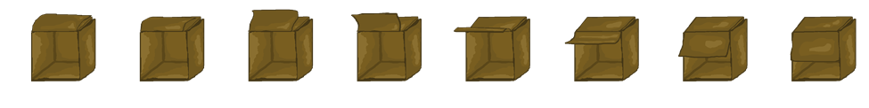The Box sprites sheets is sized at 512x512 pixels.

Figure , Box Sprites

* 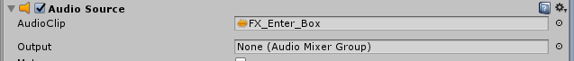The animation plays when a cat enters or exits the box.

Figure , Box Audio Source Component

### Box Sound

The FX_Enter_Box is on the Audio Source component attached to the box. It activates when the player enters and exits the box.

## Hose and Water

* The hose is around the level shooting out water which blocks the path of the cats.
* The water blocks the path and field of view of the dogs.
* If a cat or dog ends their turn on the hose, then the water unblocks the path.

### Hose and Water Conveyance

* The hose will be on top of the node that the player can stand on.
* A particle effect system shoots out blue particles to show where the player or dog should stand on the hose.
* The water is displayed at the end of the hose spout through a vicious blue particle effect system covering the node path.

### Hose and Water Placement

Figure , Hose Prefab

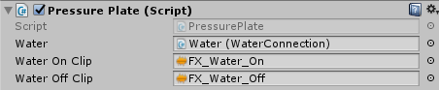

Figure , Pressure Plate Script

* + The FX_Water_On and FX_Water_Off audio source are attached to the pressure plate script and activates when the player goes on or off the hose leak respectively.
  + Each pressure plate object corresponds to a unique water object, which is a child of the pressure plate in hierarchy menu.
  + 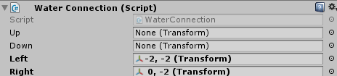Each pressure plate has a Pressure Plate script, turning on/off the water.

Figure , Watter Connection Script

* + Each water object has a WaterConnection script, indicating the path it is blocking.
  + When editing the level, check each WaterConnection and put proper node object into the script according to the water’s blocking path.

## Invisible Objects

* To make sure that blocked paths are not visible to the dog’s checks the LDs must place the Invisible Object prefab to block the line of sight.
* The Invisible Objects show up as white boxes that the LDs can transform to fit any area, and become invisible on the start of a level.

### Invisible Object Placement

* When editing the level, put box elements above proper node according to the level layout. There’s no other script setting required for box elements.

## Cat Nip

* The cat nip is an additional pick up/challenge for the player to get in the last 10 levels.
* The cat nip spins around on a node.
* The cat nip disappears when a cat lands on the same node.

### Cat Nip Placement

* When editing the level, put catnip elements above proper node according to the level layout. There’s no other script setting required for catnip elements.

### Cat Nip Art

Figure , Cat Nip Sprites

* The Cat Nip sprite sheet is sized at 128x128 pixels.



### Base Background Asset Sprites

* Base assets for the background and environment
* 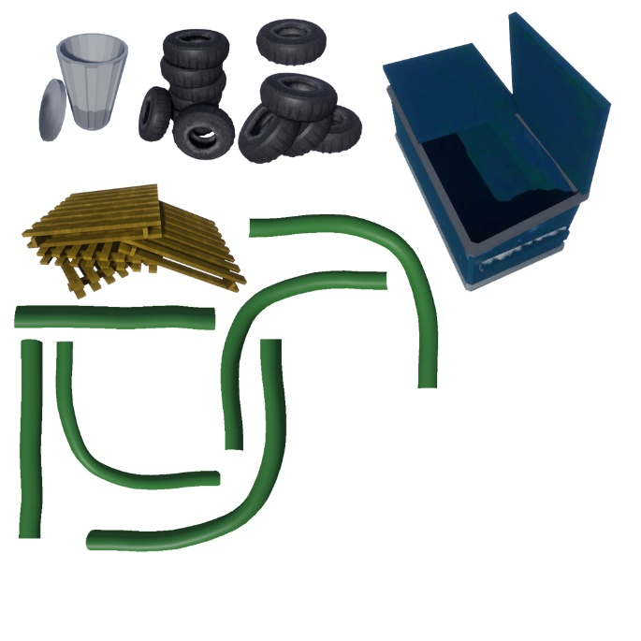All assets are set to 1024x1024 for ease of import and scaling

Figure , Background Art Sprites

### Modified Background Asset Sprites

* All modified assets for the background
* 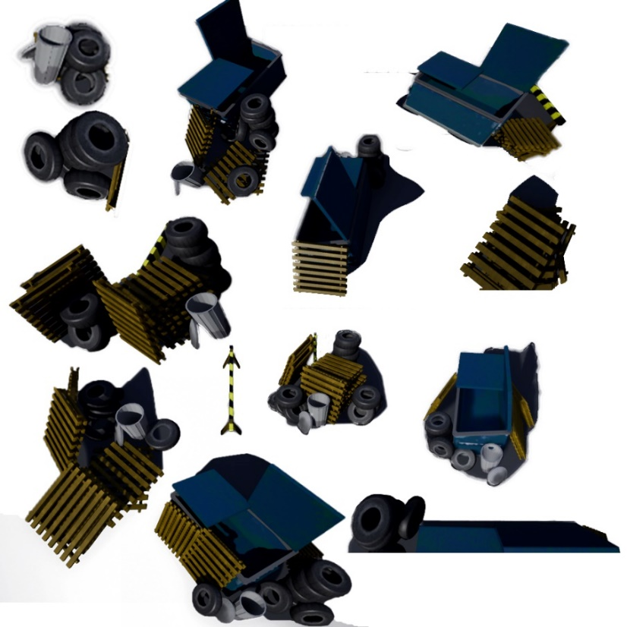All modified assets are set to 1024x1024 for ease of scaling and uniformity

Figure , Modified Background Art Sprites

## Camera/HUD/UI

A4

A3

A2

A1

Figure , UI

* The camera is placed in an isometric view of the alley way.
* A1 takes players to the pause menu.
* A2 restarts the current level.
* A3 tells players which level they are on
* A4 is the turn counter.

# World Layout

Level Progression and Details 27

Level Progression Table 27

Level 1: Tutorial 1 28

Level 2: Tutorial 2 28

Level 3: Tutorial 3 29

Level 4: Bunny 29

Level 5: Smol Tank 30

Level 6: Tank Boi 30

Level 7: Man w Cane 31

Level 8: Thicc Sticc 31

Level 9: Signs 32

Level 10: New Dog Who Dis 32

Level 11: Hummer 33

Level 12: Mirrorz 33

## Level Progression and Details

### Level Progression Table

|  |  |  |  |  |  |
| --- | --- | --- | --- | --- | --- |
| Level # | Level Title | Key Info (e.g. Challenges, Actions) | Approx. Difficulty (1-10) | Optimal Turns | Wow? |
| 1 | Tutorial 1 | 1 Dog, 0 Box, 0 Hoses, 0 Nip | 1 | 2 | Teaching basic controls. |
| 2 | Tutorial 2 | 1 Dog, 2 Boxes, 0 Hose, 0 Nip | 1 | 2 | Teaches players how to enter and exit the boxes. |
| 3 | Tutorial 3 | 1 Dog, 0 Box, 1 Hose, 1 Nip | 2 | 4 | Teaches players how the hose and water works. |
| 4 | Bunny | 1 Dog, 1 Box, 1 Hose, 1 Nip | 3 | 6 | Applying mechanics |
| 5 | Smol Tank | 1 Dog, 0 Box, 1 Hose, 1 Nip | 5 | 7 | Challenge begins to ramp up |
| 6 | Man w/ Cane | 1 Dog, 3 Boxes, 1 Hose, 1 Nip | 4 | 12 | Easy if you understand Smol Tank |
| 7 | Thicc Sticc | 1 Dog, 2 Boxes, 2 Hoses, 1 Nip | 5 | 9 | Introduces Multiple Hoses |
| 8 | Tank Boi | 1 Dog, 0 Boxes, 1 Hose, 1 Nip | 6 | 14 | Looks easy but takes some extra thought. |
| 9 | Signs | 2 Dogs, 3 Boxes, 1 Hose, 1 Nip | 6 | 13 | Introduces 2 dogs |
| 10 | New Dog Who Dis | 2 Dog, 1 Box, 3 Hose, 1 Nip | 7 | 12 | Reinforces 2 dogs and ramps up the challenge, difficult to unlock all achievements. |
| 11 | Hummer | 3 Dogs, 1 Box, 2 Hoses, 1 Nip | 7 | 12 | Introduces 3 dogs, many ways to solve |
| 12 | Mirroz | 3 Dogs, 3 Boxes, 0 Hose, 1 Nip | 8 | 18 | Final level, only has boxes and nip to challenge the players. |

### Level 1: Tutorial 1

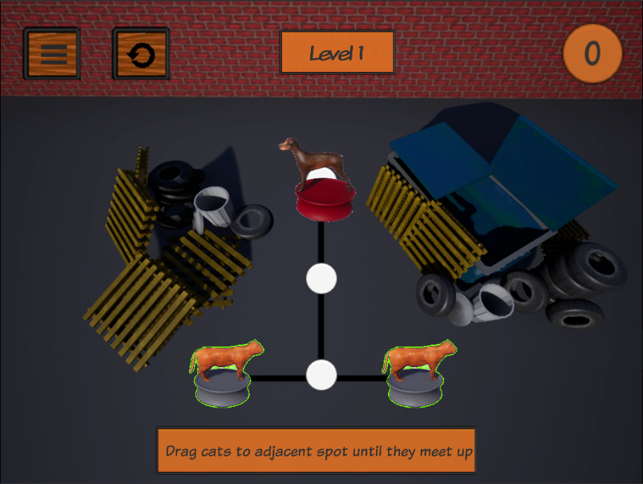

Figure 33, Tutorial 1

Introducing players to how movement and dog AI work.

### Level 2: Tutorial 2

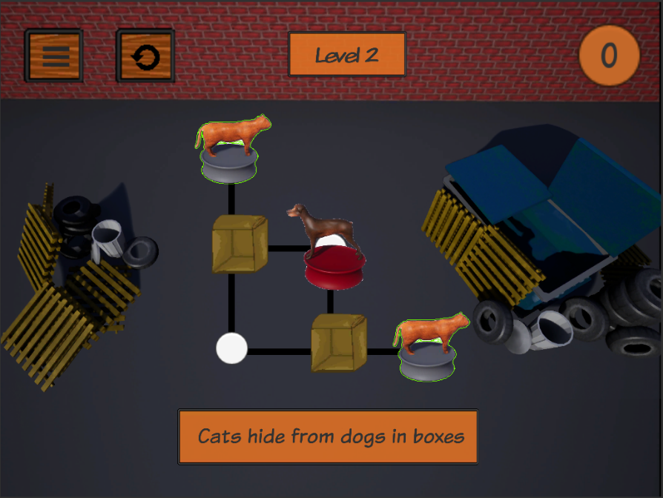

Figure 34, Tutorial 2

Introducing players to how boxes work.

### Level 3: Tutorial 3

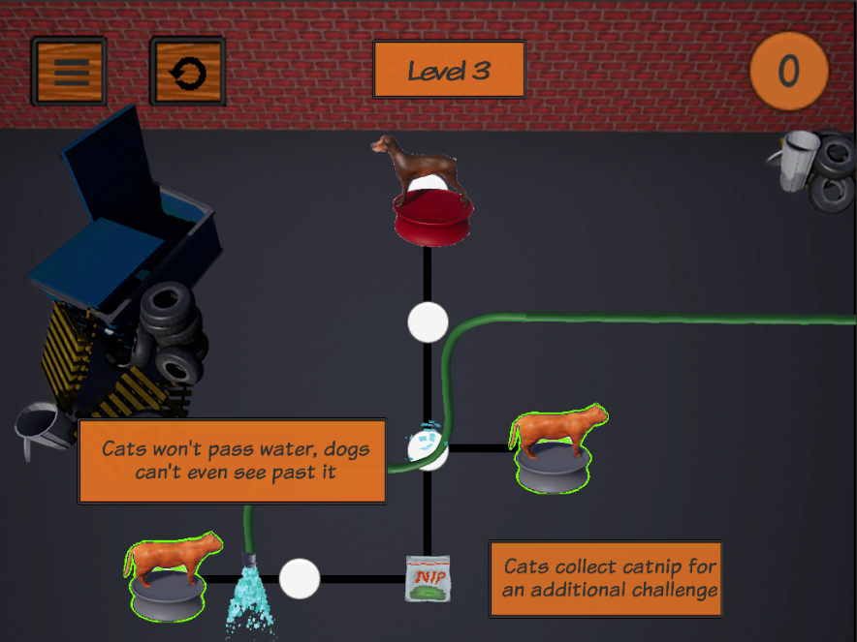

Figure 35, Tutorial 3

Introducing players to how pressure plates work.

### Level 4: Bunny

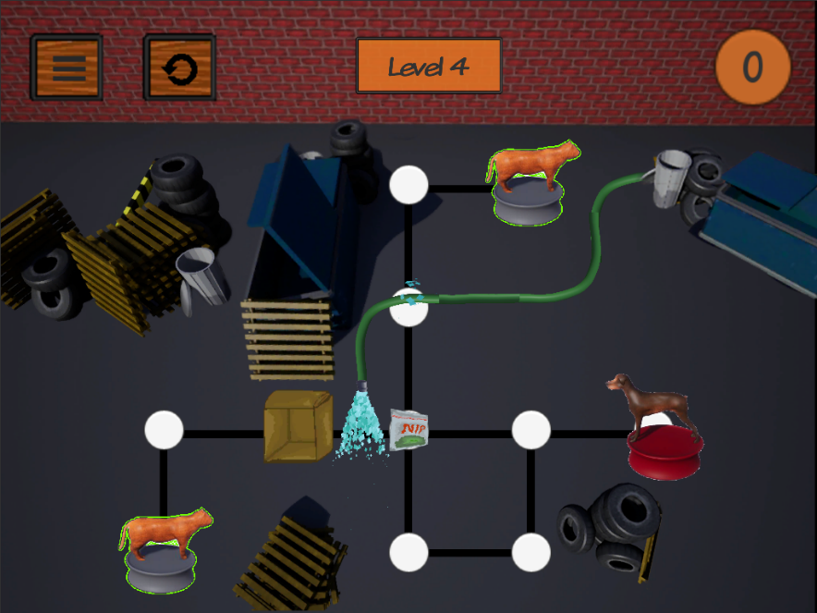

Figure 36, Bunny

Reinforces the pressure plate and box hiding mechanic to the player.

### Level 5: Smol Tank

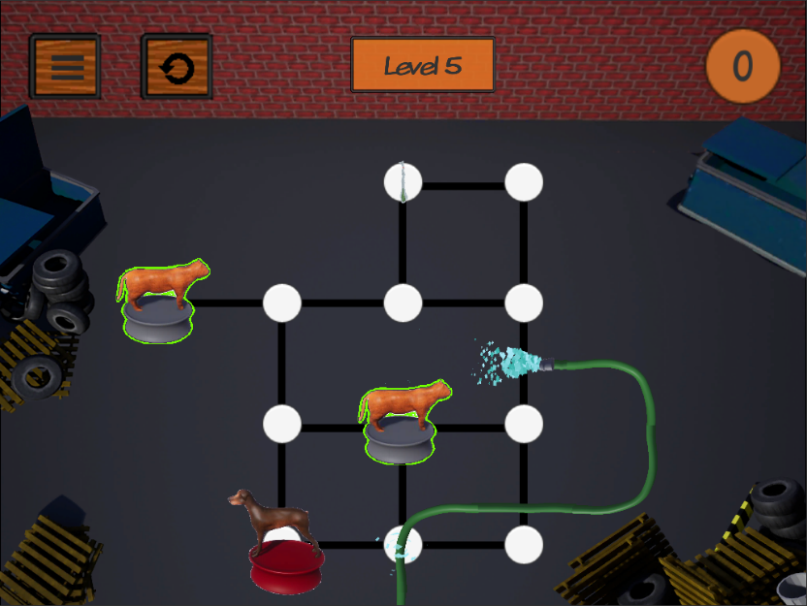

Figure 37, Smol Tank

Ramps up the challenge to the player by providing more choice in how they approach the level.

### Level 6: Tank Boi

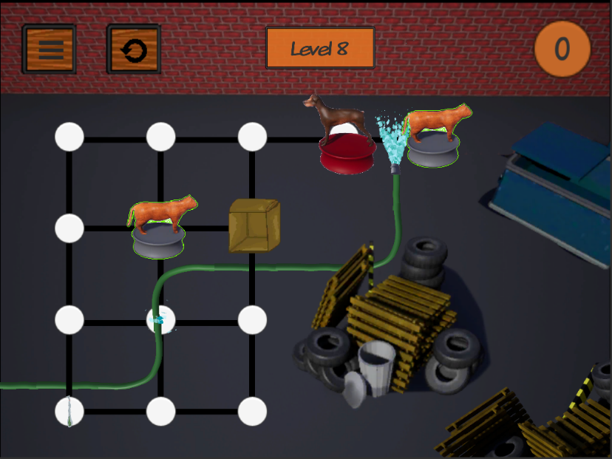

Figure 38, Tank Boi

The hardest early level in the game where we reinforce and test all the primary mechanics before putting multipliers on them.

### Level 7: Man w Cane

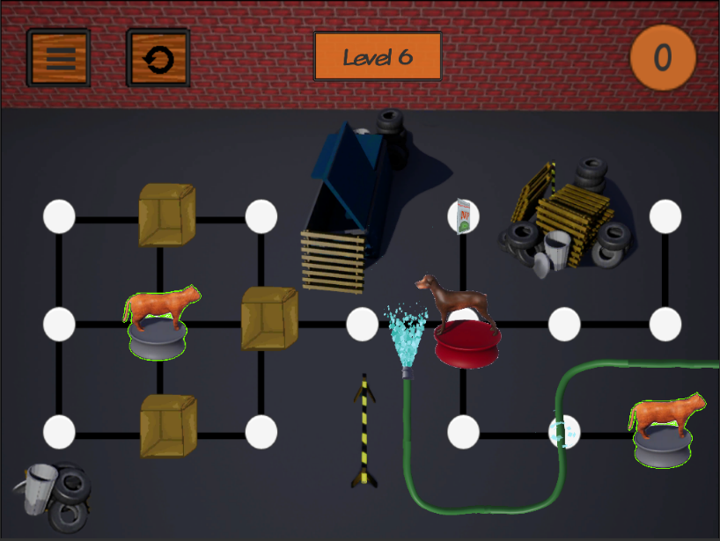

Figure 39, Man w Cane

An easier level to encourage players to think about how they need to manipulate their turns to get the dog to a desired location.

### Level 8: Thicc Sticc

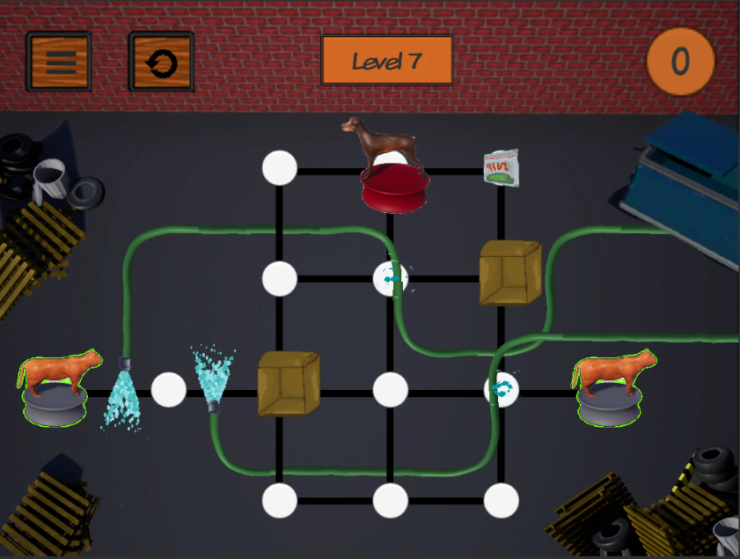

Figure 40, Thicc Sticc

Level with 3 pressure plates that is easy to beat, but hard to complete in the optimal paths and get the catnip.

### Level 9: Signs

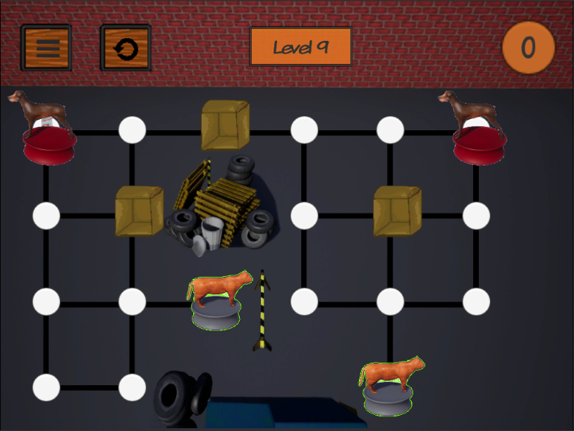

Figure 41, Signs

Introduces 2 dogs to the puzzle.

### Level 10: New Dog Who Dis

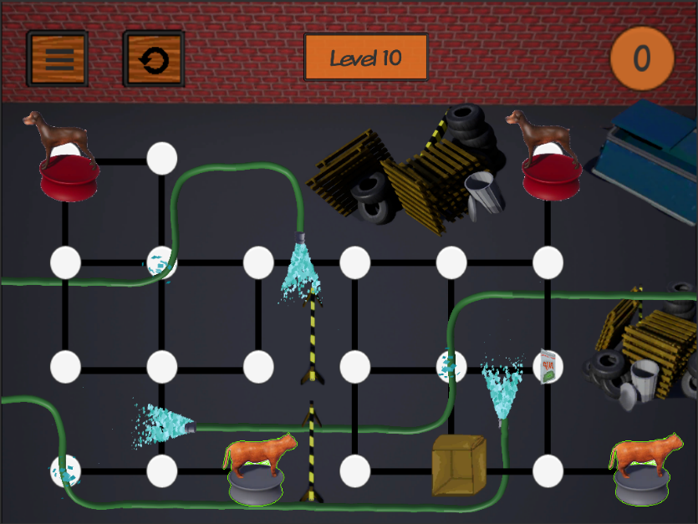

Figure 42, New Dog Who Dis

A more challenging level with 2 dogs.

### Level 11: Hummer

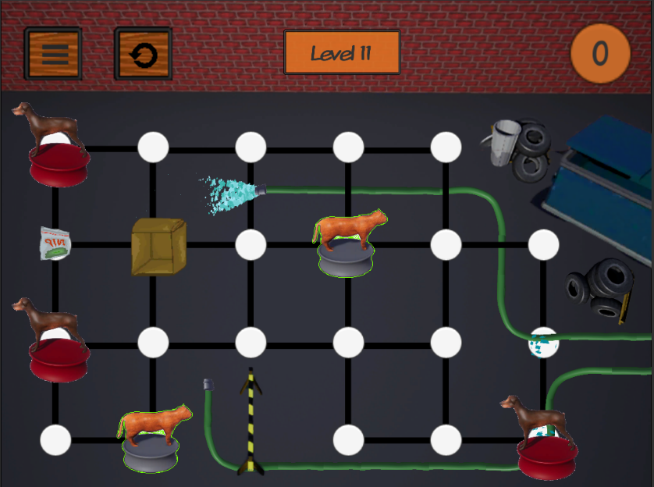

Figure 43, Hummer

Introduces 3 dogs to the puzzle

### Level 12: Mirrorz

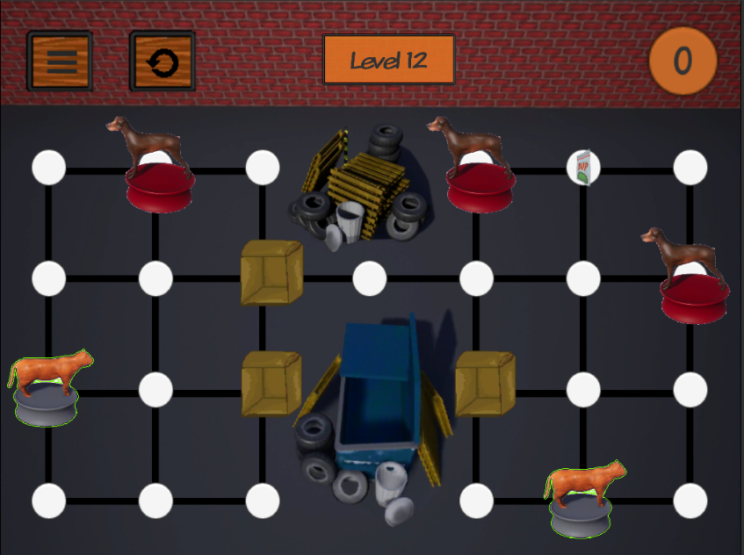

Figure 44, Mirrorz

Challenges players at the final level with 3 dogs.

# Menu System

## Menu Flow

Figure 45, Home Screen Menu Flow

Figure 46, In Level UI Flow

## Menu Descriptions

|  |  |  |
| --- | --- | --- |
| **Button Name** | **Description** | **Location** |
| Level [#] | Choses level | Home Screen |
| Restart Level Button | Restarts current level | In Level/In Level>Menu |
| Home Screen Button | Takes player to the home screen | In Level>Menu |
| Information | Tells the player what the core rules are | In Level>Menu button |
| Resume Level | Resumes current level | In Level>Menu button |
| Credits | Takes player to the credits | Home Screen |
| Play | Starts game at level 1 | Home Screen |

## Menu Details

### Installation

### Title Splash Screen(s)



Figure , Guildhall Splash Screen

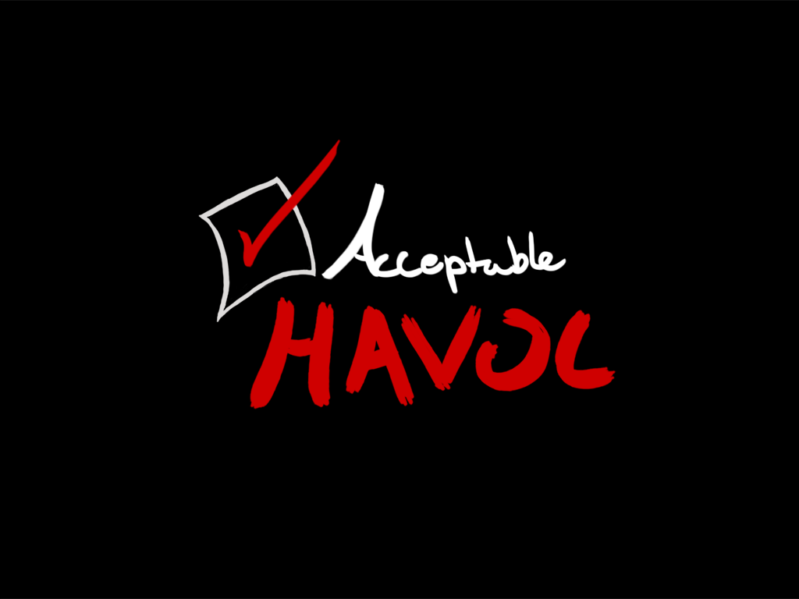

Figure , Acceptable Havoc Splash Screen

### Main Menu

### Credits Screen

Figure , Main Menu

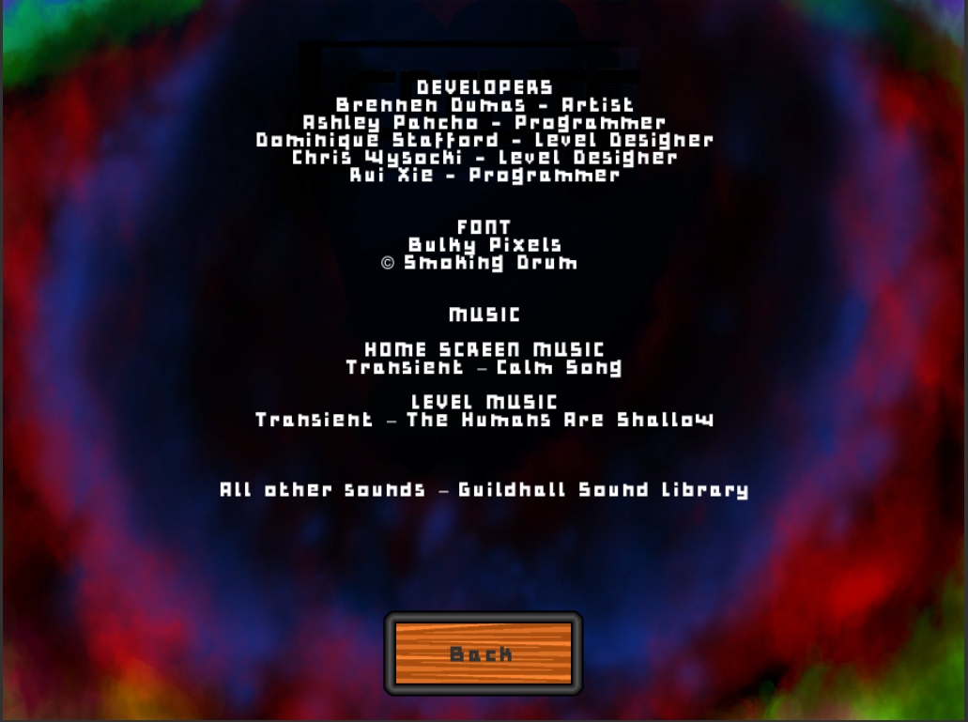

Figure , Credits

### Exit/Pause Screen

Figure , Exit/Pause Screen

### Game Over Screens

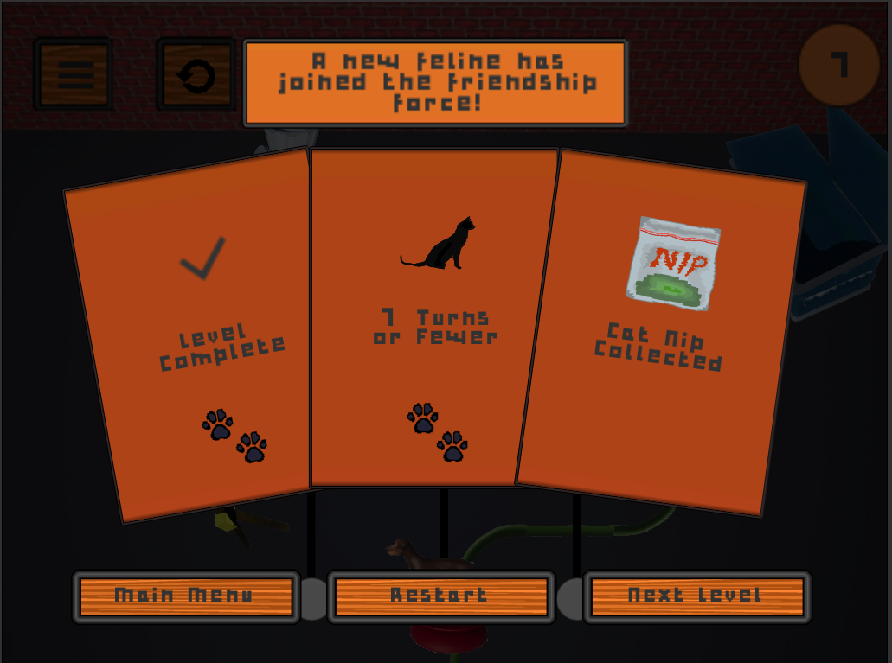Win

Figure , Win Screen

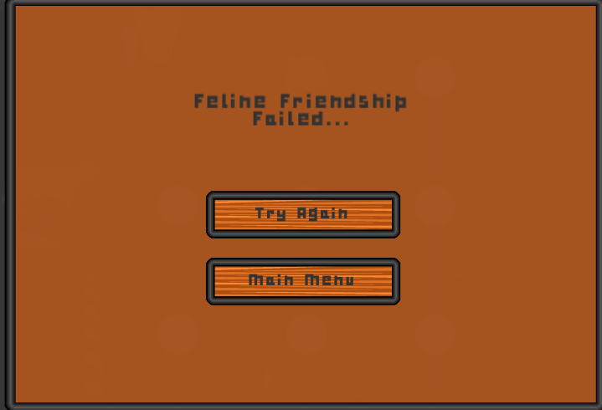*Loss*

Figure , Loss Screen